HANDS-ON EVIDENCE WRITEUP 02 / 04

Ubuntu auditd: Package-Execution Audit Trail
  - Objective → test → observed result → SOC interpretation

Objective
Enable auditd, monitor execution of /usr/bin/apt and retrieve an audited package command.

Method
Enabled auditd; used a watch on /usr/bin/apt with key nano; executed apt install nano; retrieved matching entries with sudo ausearch -k nano -i.

Evidence
The image shows type=EXECVE with argc=3, a0=apt, a1=install, a2=nano; records include SYSCALL, PATH, CWD and user/session fields.

SOC significance
Command execution, actor and executable-path context can confirm administrator actions and support investigation of suspicious software installs.
sudo systemctl enable auditd --now
sudo auditctl -w /usr/bin/apt -p x -k nano
sudo apt install nano
sudo ausearch -k nano -i
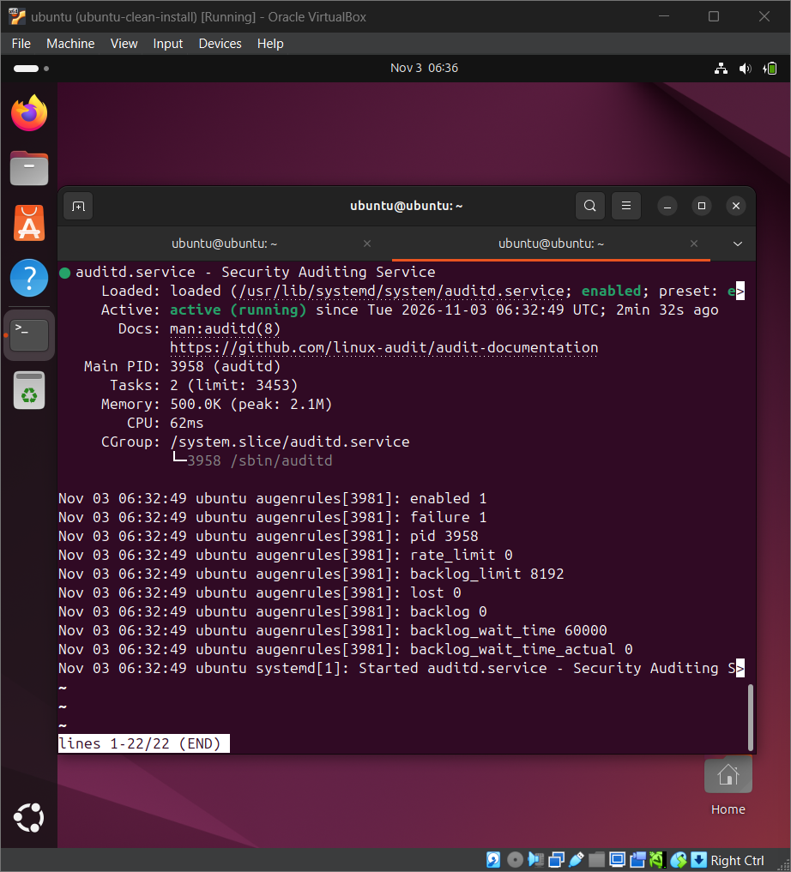
01 Auditd Service Status
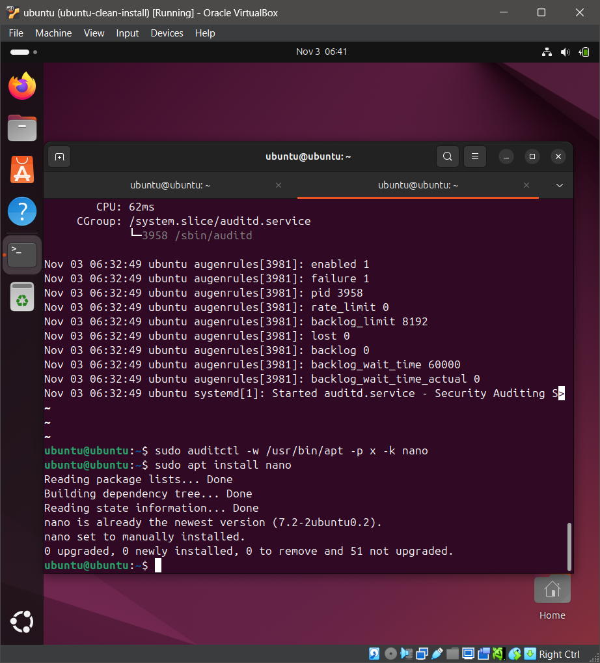
02 Auditd APT Command
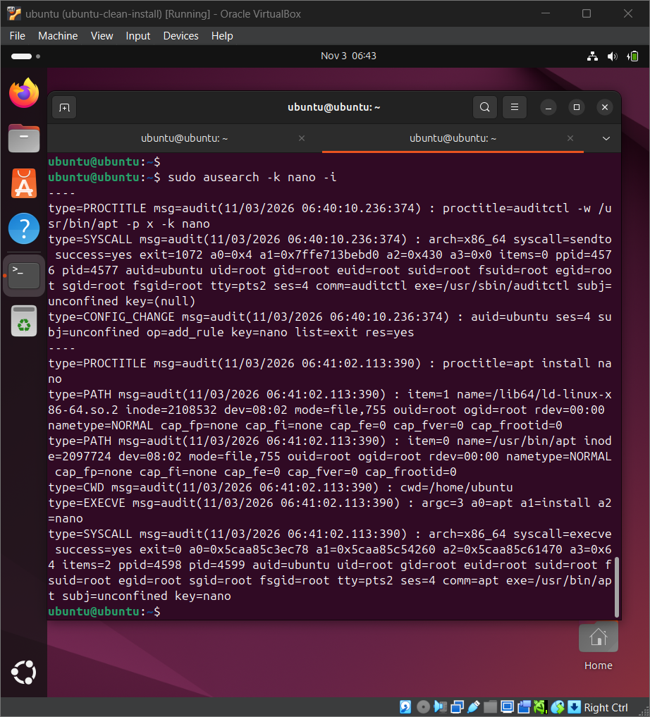
03 Auditd Ausearch Results

